### **Mera - Your AI Dermatologist Assistant**

### **Project Structure**

1. **Data Ingestion (Excel + PyPDF Processing)**

Preprocesses an **Excel file** by removing irrelevant data, handling missing values, and selecting useful dermatology-related information. The cleaned data is converted into a **PDF**, from which text is extracted using **PyPDF** for further processing.

1. **Text Chunking & Preprocessing**Splits extracted text into smaller, meaningful chunks. Cleans, tokenizes, and standardizes the text for accurate retrieval.
2. **Embedding Generation**Converts text chunks into numerical embeddings using **sentence-transformers** for efficient similarity searches and retrieval.
3. **Vector Database (FAISS for Fast Search)**Stores embeddings in **FAISS**, allowing rapid nearest-neighbor searches for relevant dermatological data.
4. **Retrieval Setup**

Uses FAISS-based retriever to fetch the top three most relevant chunks based on similarity search, ensuring precise and contextually relevant information retrieval.

**Memory for Conversation Context**

Implements a conversation memory buffer to retain chat history, allowing for context-aware responses and seamless user interaction.

**System Prompt Configuration**

Defines a structured system prompt to guide the AI’s responses, ensuring medically accurate, professional, and user-friendly answers in dermatology-related queries.

1. **Query Processing & Context Retrieval**

Converts user queries into embeddings and retrieves relevant data from FAISS. If no match is found, it scrapes **Clinikally** for relevant information. If still unavailable, it fetches results from **DuckDuckGo**.

1. **LLM Response Generation (OpenAI API)**Passes retrieved context to OpenAI’s model for generating accurate, natural-language responses.
2. **Frontend (FastAPI + HTML/CSS/Bootstrap)**Provides an interactive UI with FastAPI as the backend and Bootstrap for design. Users can upload files and ask dermatology-related queries.
3. **Deployment (AWS + Localhost)**Runs locally for development, with embeddings stored on AWS for scalable deployment.
4. **Image Processing (Future Scope)**Dermatology images can be **vectorized into embeddings** for better diagnosis using deep learning models like **ResNet**.

**Notebook Link :**

<https://github.com/GauravAnand30/Mera-AI-Dermatologist-Assistant/blob/main/trials.ipynb>

**Github Link:** [**https://github.com/GauravAnand30/Mera-AI-Dermatologist-Assistant**](https://github.com/GauravAnand30/Mera-AI-Dermatologist-Assistant)

**Video Demo Link :**

<https://drive.google.com/file/d/1ZsPi02_yKlig0wt_W-PkwJ-jWYQyt1R_/view?usp=sharing>

**Screenshots Link :**

<https://drive.google.com/drive/u/0/folders/12CONIXXGkokxpXwG6c-bIPKSw7vyuTVM>

**Meet Mera**

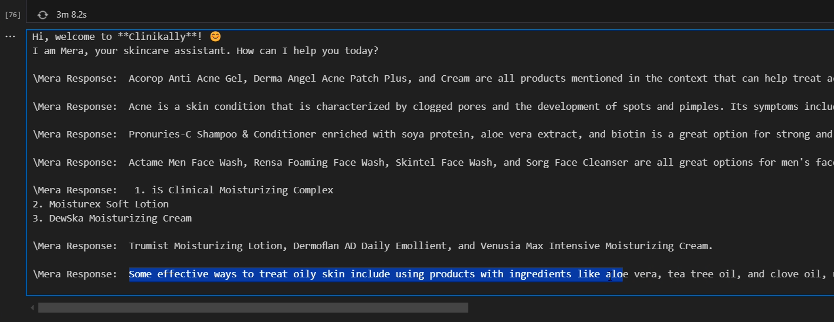

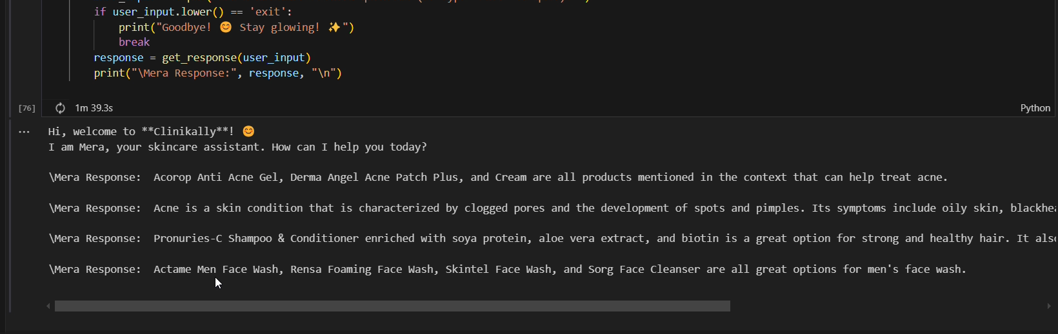

1. **Data Ingestion (Excel + PyPDF Processing)**

Preprocesses an **Excel file** by removing irrelevant data, handling missing values, and selecting useful dermatology-related information. The cleaned data is converted into a **PDF**, from which text is extracted using **PyPDF** for further processing.  
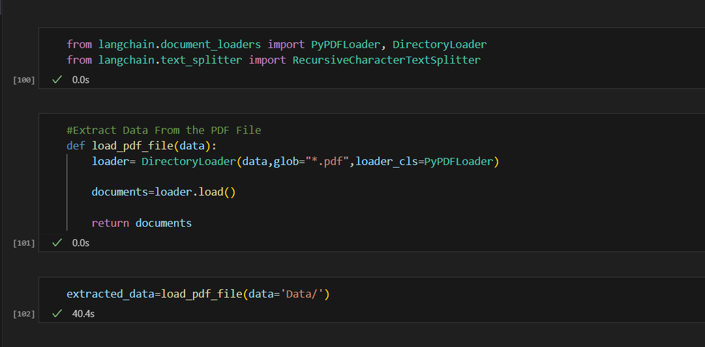

1. **Text Chunking & Preprocessing**

Splits extracted text into smaller, meaningful chunks. Cleans, tokenizes, and standardizes the text for accurate retrieval.

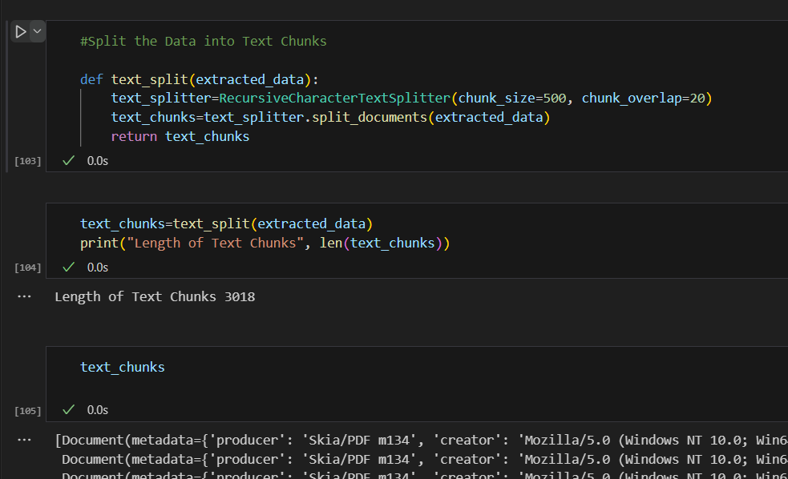

1. **Embedding Generation**Converts text chunks into numerical embeddings using **sentence-transformers** for efficient similarity searches and retrieval.

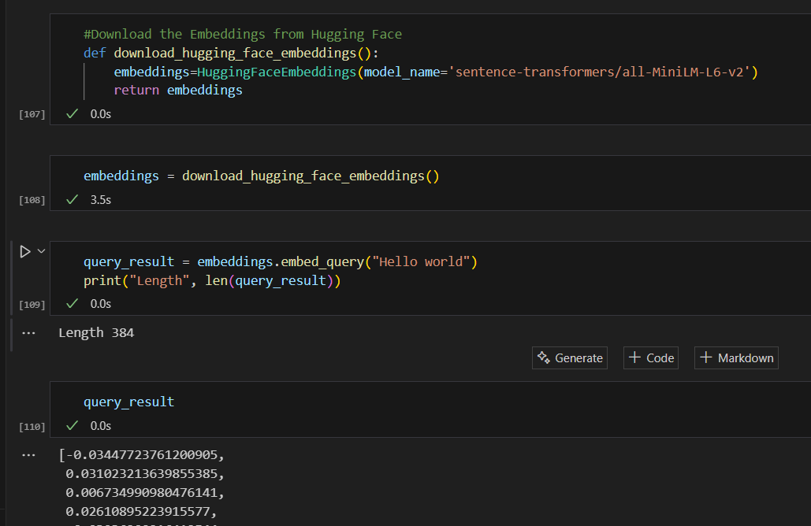

1. **Vector Database (FAISS for Fast Search)**Stores embeddings in **FAISS**, allowing rapid nearest-neighbor searches for relevant dermatological data.

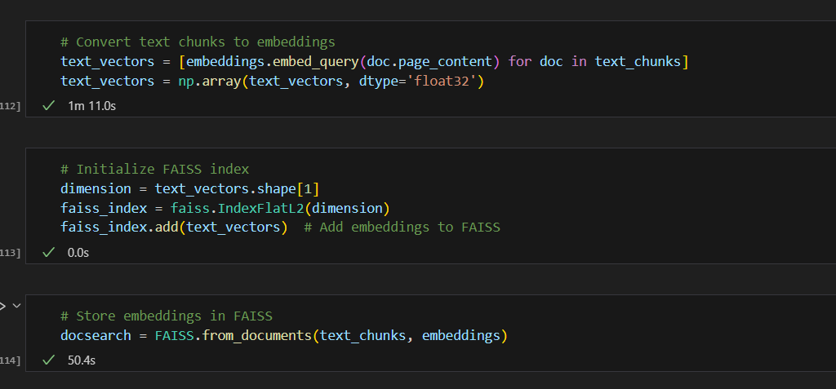

1. **Retrieval Setup**

Uses FAISS-based retriever to fetch the top three most relevant chunks based on similarity search, ensuring precise and contextually relevant information retrieval.

**Memory for Conversation Context**

Implements a conversation memory buffer to retain chat history, allowing for context-aware responses and seamless user interaction.

**System Prompt Configuration**

Defines a structured system prompt to guide the AI’s responses, ensuring medically accurate, professional, and user-friendly answers in dermatology-related queries.

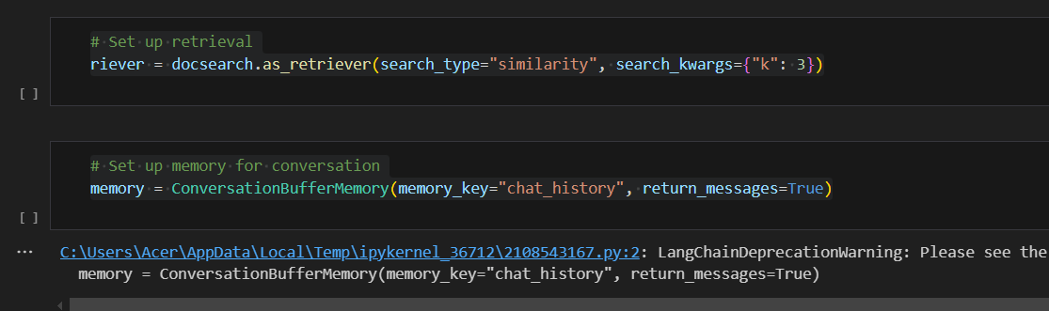

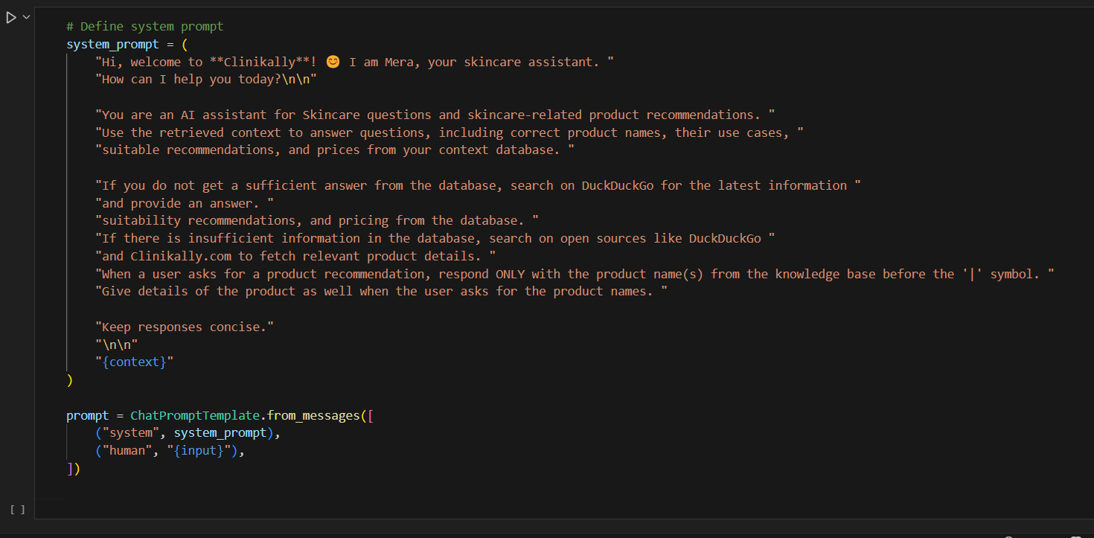

1. **Query Processing & Context Retrieval**

Converts user queries into embeddings and retrieves relevant data from FAISS. If no match is found, it scrapes **Clinikally** for relevant information. If still unavailable, it fetches results from **DuckDuckGo**.

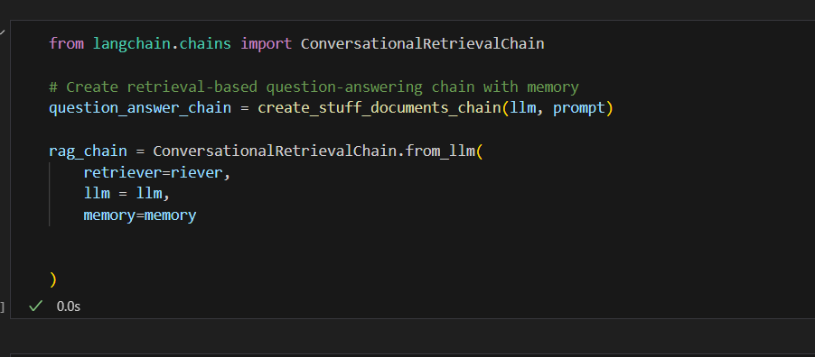

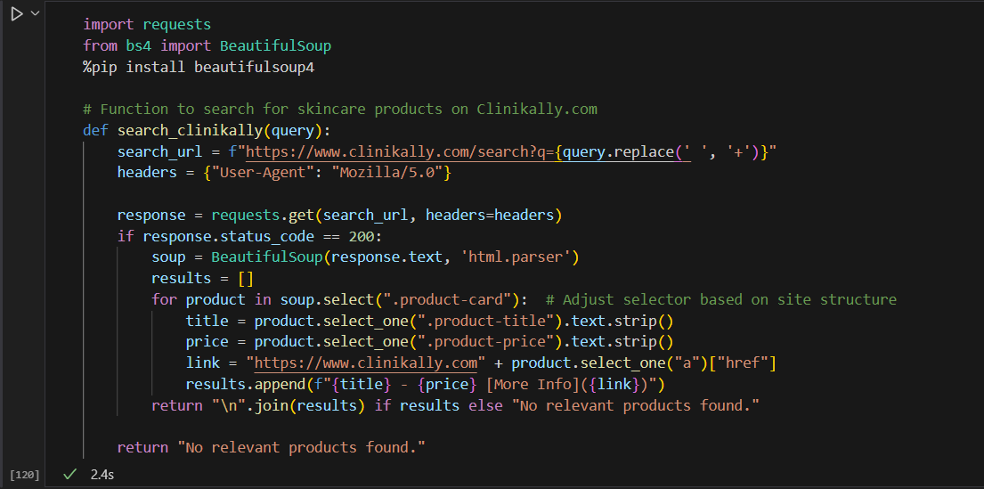

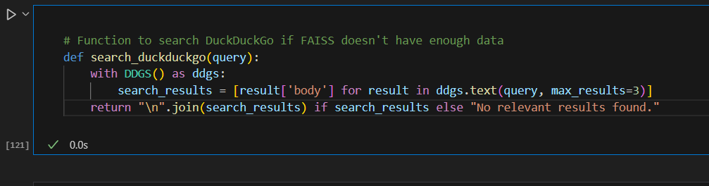

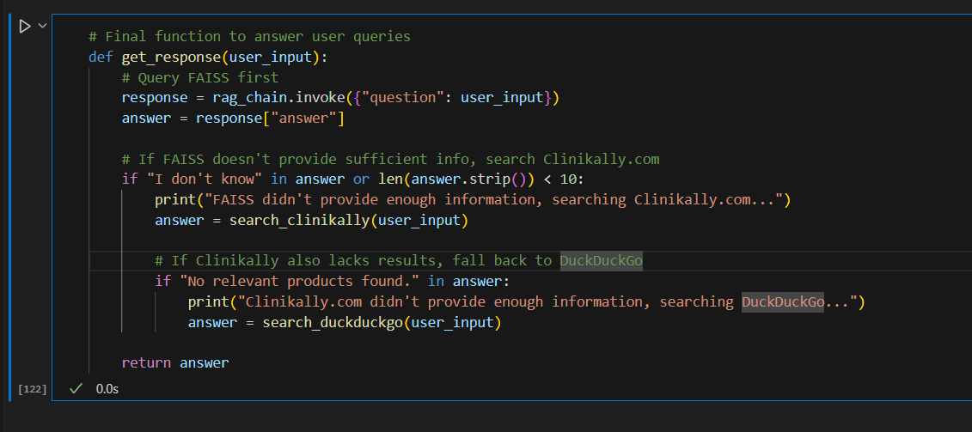

1. **LLM Response Generation (OpenAI API)**Passes retrieved context to OpenAI’s model for generating accurate, natural-language responses.

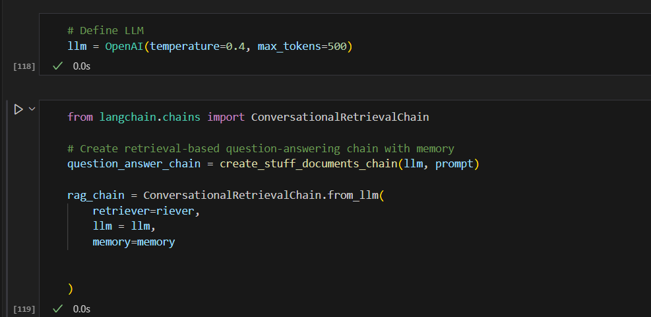

**Responses Answers from Mera**

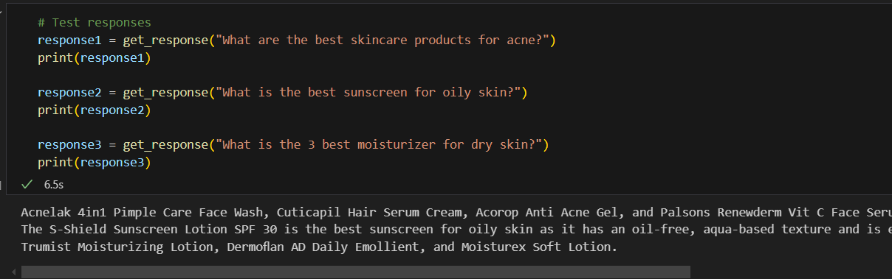

**Responses from Mera**

**Acnelak 4in1 Pimple Care Face Wash, Cuticapil Hair Serum Cream, Acorop Anti Acne Gel, and Palsons Renewderm Vit C Face Serum are all effective skincare products for acne.**

**The S-Shield Sunscreen Lotion SPF 30 is the best sunscreen for oily skin as it has an oil-free, aqua-based texture and is enriched with vitamin E, Allantoin, and green tea extract to nourish the skin while providing broad-spectrum protection against UV-A and UV-B radiation.**

**Trumist Moisturizing Lotion, Dermoﬂan AD Daily Emollient, and Moisturex Soft Lotion.**

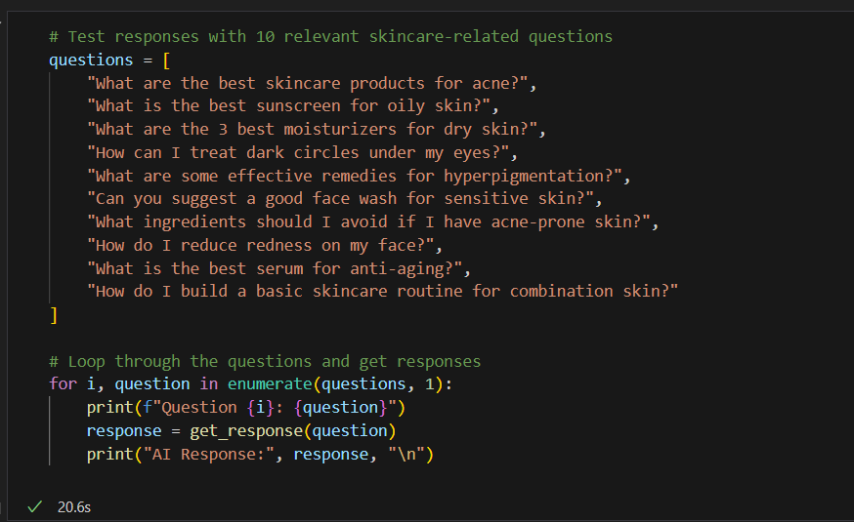

**Responses**

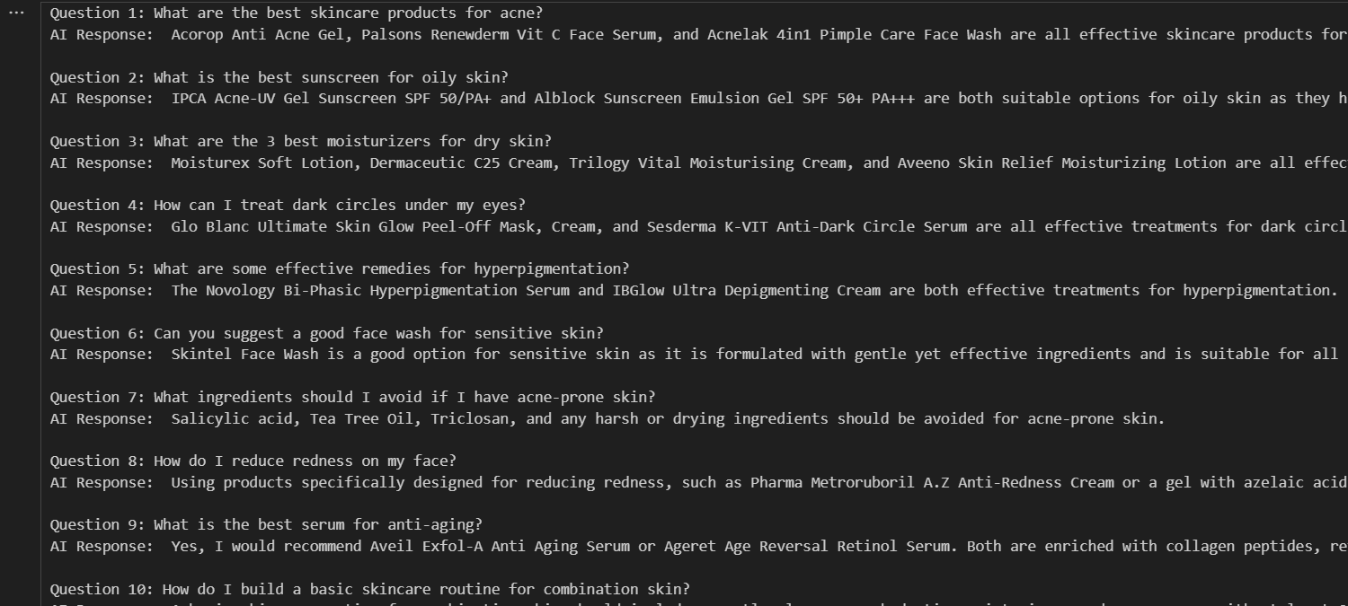

**Question 1: What are the best skincare products for acne?**

**AI Response: Acorop Anti Acne Gel, Palsons Renewderm Vit C Face Serum, and Acnelak 4in1 Pimple Care Face Wash are all effective skincare products for acne.**

**Question 2: What is the best sunscreen for oily skin?**

**AI Response: IPCA Acne-UV Gel Sunscreen SPF 50/PA+ and Alblock Sunscreen Emulsion Gel SPF 50+ PA+++ are both suitable options for oily skin as they have a lightweight, non-greasy formula. Sunprotek Sunscreen Gel SPF 30+ PA+++ is also a good option for oily skin, but it may not be as lightweight as the other two options. Ultimately, it is important to choose a sunscreen with at least SPF 30 and broad-spectrum protection for optimal sun protection.**

**Question 3: What are the 3 best moisturizers for dry skin?**

**AI Response: Moisturex Soft Lotion, Dermaceutic C25 Cream, Trilogy Vital Moisturising Cream, and Aveeno Skin Relief Moisturizing Lotion are all effective moisturizers for dry skin.**

**Question 4: How can I treat dark circles under my eyes?**

**AI Response: Glo Blanc Ultimate Skin Glow Peel-Off Mask, Cream, and Sesderma K-VIT Anti-Dark Circle Serum are all effective treatments for dark circles under the eyes.**

**Question 5: What are some effective remedies for hyperpigmentation?**

**AI Response: The Novology Bi-Phasic Hyperpigmentation Serum and IBGlow Ultra Depigmenting Cream are both effective treatments for hyperpigmentation.**

**Question 6: Can you suggest a good face wash for sensitive skin?**

**AI Response: Skintel Face Wash is a good option for sensitive skin as it is formulated with gentle yet effective ingredients and is suitable for all skin types.**

**Question 7: What ingredients should I avoid if I have acne-prone skin?**

**AI Response: Salicylic acid, Tea Tree Oil, Triclosan, and any harsh or drying ingredients should be avoided for acne-prone skin.**

**Question 8: How do I reduce redness on my face?**

**AI Response: Using products specifically designed for reducing redness, such as Pharma Metroruboril A.Z Anti-Redness Cream or a gel with azelaic acid, can be effective in reducing facial redness. Additionally, maintaining a regular skincare routine and avoiding triggers for redness, such as harsh products or excessive sun exposure, can also help.**

**Question 9: What is the best serum for anti-aging?**

**AI Response: Yes, I would recommend Aveil Exfol-A Anti Aging Serum or Ageret Age Reversal Retinol Serum. Both are enriched with collagen peptides, retinol, and other essential nutrients to reduce the appearance of fine lines and wrinkles, improve skin elasticity, and promote a youthful glow. They are suitable for all skin types and can be used daily or nightly for best results.**

**Question 10: How do I build a basic skincare routine for combination skin?**

**AI Response: A basic skincare routine for combination skin should include a gentle cleanser, a hydrating moisturizer, and a sunscreen with at least SPF 30. It is also important to exfoliate regularly to remove dead skin cells and balance out the different areas of your skin. Additionally, incorporating a toner and serum can help target specific skin concerns. Be sure to patch test any new products and listen to your skin's needs to adjust your routine accordingly.**

### **Future Scope**

* Image Processing: Use deep learning models (ResNet, EfficientNet) to analyze dermatology images and classify skin conditions.
* AWS Deployment: Deploy on AWS SageMaker, EC2 (GPU), and Lambda for scalable AI services.
* Serverless Architecture: Use API Gateway, DynamoDB, and S3 for cost-effective cloud storage and processing.
* Real-time Monitoring: Implement AWS X-Ray and CloudWatch for tracking API performance and response times.
* Response Optimization: Store query logs in AWS Athena to refine AI recommendations and enhance accuracy.